Practical 7 - Programs on Basic jQuery

Practical 7. a)

Aim: jQuery Basic, jQuery Events

Solution:

1. Write a Jquery to Change text contents of the elements on button click.

Code:

<!doctype html>

<html>

<head>

    <title>Online jQuery Editor</title>

    <script src="jquery.js"></script>

    <script>

        $(document).ready(function() {

                {

                    $("button").click(

                        function() {

                            document.write("hello world");

                        }

                    );

                }

                });

    </script>

</head>

<body>

    <p>Hello! Welcome in Jquery Language!!</p>

    <button>Click me</button>

</body>

</html>

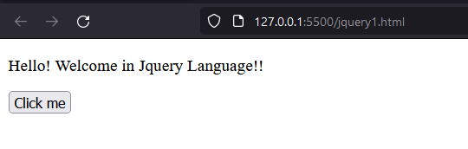Output:

1. Write a Jquery to Select elements by class name,id and element name.

Code:

<!DOCTYPE html>

<html>

  <head>

    <title></title>

    <script src="jquery.js"></script>

    <script>

      $(document).ready(function () {

        $(".class1").css("background", "#ADF7F7");

        $("#id1").css("background", "#DEC7FF");

        $("h2").css("background", "#C5F0D0");

      });

    </script>

  </head>

  <body>

    <p class="class1">Hello!</p>

    <p id="id1">Students</p>

    <h2>welcome in jquery Language!!</h2>

  </body>

</html>

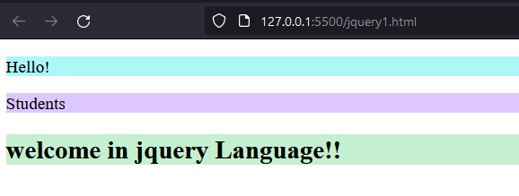Output:

1. Write a Jquery to show the use of Click(), hover(), on(), trigger(), off() events.

Code:

<!DOCTYPE html>

<html>

  <head>

    <title></title>

    <script src="jquery.js"></script>

    <script>

      $(document).ready(function () {

        $("#b1").hover(function () {

          document.write("hello world");

        });

        $("p").on("click", function () {

          $(this).css("background-color", "pink");

        });

        $("#b2").click(function () {

          $("p").off("click");

        });

        $("#b3").on("click", function () {

          $("#t1").hide();

        });

        $("input").select(function () {

          $("input").after(" Text marked!");

        });

        $("#b4").click(function () {

          $("input").trigger("select");

        });

      });

    </script>

  </head>

  <body>

    <button id="b1">hover</button><br />

    <p>hello welcome in Mulund college of commerce!!</p>

    <p>TYIT students</p>

    <button id="b2">off</button><br /><br />

    <p id="t1">Hello world</p>

    <br />

    <button id="b3">on</button><br /><br />

    <input type="text" value="Hello World" /><br /><br />

    <button id="b4">trigger</button>

  </body>

</html>

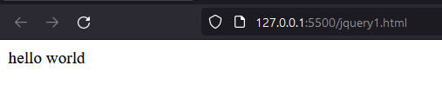Output:

After Hovering on Hover Button

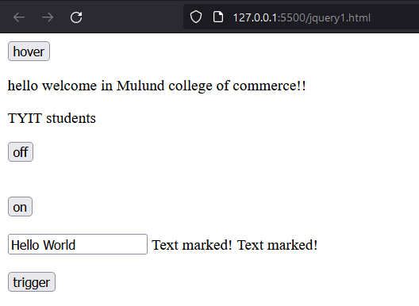

Practical 7.b)

Aim: jQuery Selectors, jQuery Hide and Show effects.

1. Write a Jquery to Create animated show hide effect.

Code:

<!DOCTYPE html>

<html>

  <head>

    <title></title>

    <script src="jquery.js"></script>

    <script>

      $(document).ready(function () {

        $("#b1").click(function () {

          $("p").hide();

        });

        $("#b2").click(function () {

          $("p").show();

        });

      });

    </script>

  </head>

  <body>

    <p>Mulund College Of Commerce</p>

    <button id="b1">Hide</button>

    <button id="b2">Show</button>

  </body>

</html>

Output:

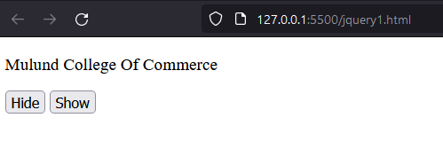After clicking Show Button

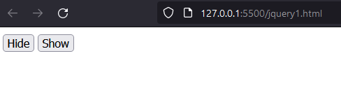After Clicking Hide Button

1. Write a Jquery to create a simple toggle effect.

Code:

<!DOCTYPE html>

<html>

  <head>

    <title></title>

    <script src="jquery.js"></script>

    <script>

      $(document).ready(function () {

        $("button").click(function () {

          $("p").toggle();

        });

      });

    </script>

  </head>

  <body>

    <p>Lorem ipsum dolor sit amet, consectetur adipiscing elit, sed do eiusmod tempor incididunt ut labore et dolore magna aliqua.</p>

    <button>Toggle between hide() and show()</button>

  </body>

</html>

Output:

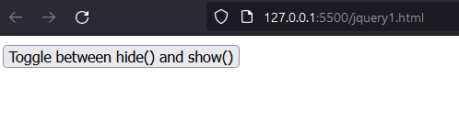

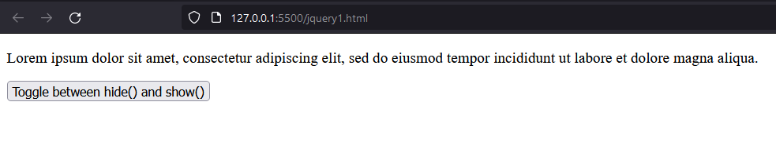

Practical 7.c)

Aim: jQuery fading effects, jQuery Sliding effects

1. Write a Jquery to create fade-in and fade-out effect.

Code:

<!DOCTYPE html>

<html>

  <head>

    <title></title>

    <script src="jquery.js"></script>

    <script>

      $(document).ready(function () {

        $(".btn1").click(function () {

          $("p").fadeOut();

        });

        $(".btn2").click(function () {

          $("p").fadeIn();

        });

      });

    </script>

  </head>

  <body>

    <p>SIES college of arts science and commerce</p>

    <button class="btn1">Fade out</button>

    <button class="btn2">Fade in</button>

  </body>

</html>

Output:

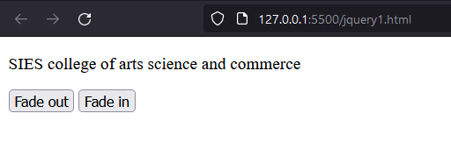

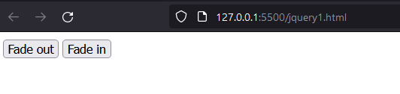

1. Write a Jquery to Create fade toggle effect.

Code:

<!DOCTYPE html>

<html>

  <head>

    <title></title>

    <script src="jquery.js"></script>

    <script>

      $(document).ready(function () {

        $(".toggle-btn").click(function () {

          $("p").fadeToggle();

        });

      });

    </script>

  </head>

  <body>

    <button type="button" class="toggle-btn">click</button>

    <p>This is a paragraph.</p>

    <p>This is another paragraph.</p>

  </body>

</html>

Output:

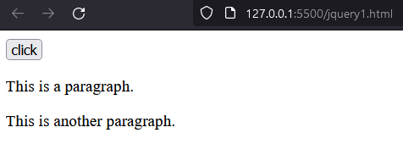

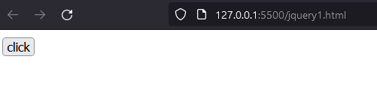

1. Write a Jquery to Create slide-up and slide-down effect.

Code:

<!DOCTYPE html>

<html>

  <head>

    <title></title>

    <script src="jquery.js"></script>

    <script>

      $(document).ready(function () {

        $(".up-btn").click(function () {

          $("p").slideUp();

        });

        $(".down-btn").click(function () {

          $("p").slideDown();

        });

      });

    </script>

  </head>

  <body>

    <button type="button" class="up-btn">Slide Up Paragraphs</button>

    <button type="button" class="down-btn">Slide Down Paragraphs</button>

    <p>This is a paragraph.</p>

    <p>This is another paragraph.</p>

  </body>

</html>

Output:

Slide Down effect

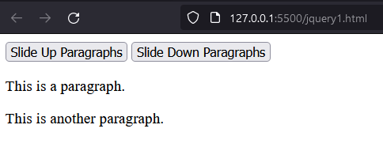

Slide Up effect

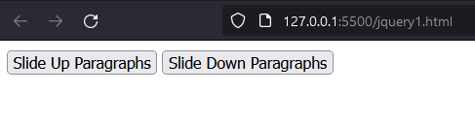

1. Write a Jquery to Create slide toggle effect.

Code:

<!DOCTYPE html>

<html>

  <head>

    <title></title>

    <script src="jquery.js"></script>

    <script>

      $(document).ready(function () {

        $(".toggle-btn").click(function () {

          $("p").slideToggle();

        });

      });

    </script>

  </head>

  <body>

    <button type="button" class="toggle-btn">Slide Toggle Paragraphs</button>

    <p>This is a paragraph.</p>

    <p>This is another paragraph.</p>

  </body>

</html>

Output:

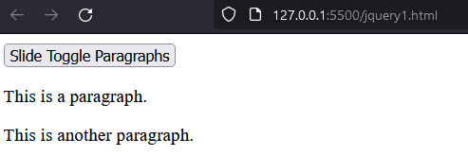

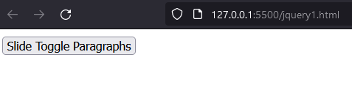

Practical 8 - jQuery Advanced

Practical 8.a)

Aim: jQuery Animation effects, jQuery Chaining.

1. Write a Jquery Create animation effect.

Code:

<!DOCTYPE html>

<html>

  <head>

    <title></title>

    <script src="jquery.js"></script>

    <style>

      img {

        position: relative; /\* Required to move element \*/

      }

    </style>

    <script>

      $(document).ready(function () {

        $("button").click(function () {

          $("img").animate({ left: 300 });

        });

      });

    </script>

  </head>

  <body>

    <button>Start Animation</button><br />

    <img src="jquery.png" alt="jQuery" height="270px" width="240px" />

  </body>

</html>

Output:

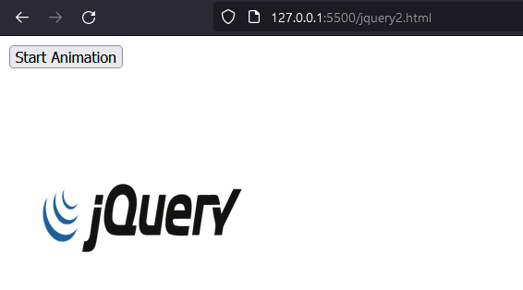

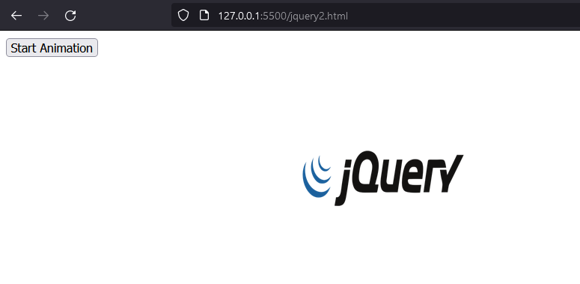

1. Write a Jquery to animate multiple CSS properties.

Code:

<!DOCTYPE html>

<html>

  <head>

    <title></title>

    <script src="jquery.js"></script>

    <style type="text/css">

      .box {

        width: 100px;

        height: 100px;

        background: #9d7ede;

        margin-top: 30px;

        border-style: solid;

        border-color: #6f40ce;

      }

    </style>

    <script>

      $(document).ready(function () {

        $("button").click(function () {

          $(".box").animate({

            width: "300px",

            height: "300px",

            marginLeft: "150px",

            borderWidth: "10px",

            opacity: 0.5,

          });

        });

      });

    </script>

  </head>

  <body>

    <button type="button">Start Animation</button>

    <div class="box"></div>

  </body>

</html>

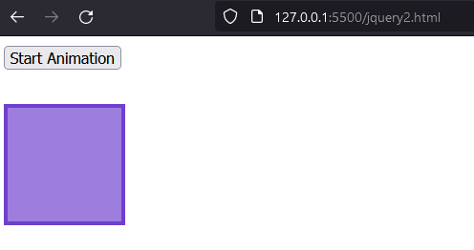Output:

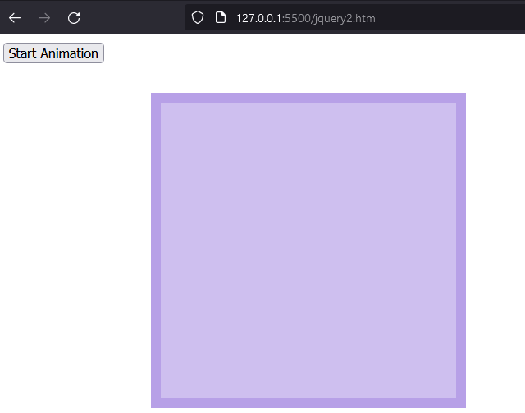

1. Write a Jquery to perform Method chaining.

Code:

<!DOCTYPE html>

<html>

  <head>

    <title></title>

    <script src="jquery.js"></script>

    <script>

      $(document).ready(function () {

        $("button").click(function () {

          $("#p1").css("color", "red").slideUp(2000).slideDown(2000);

        });

      });

    </script>

  </head>

  <body>

    <p id="p1">Welcome in jQuery!!</p>

    <button>Click me</button>

  </body>

</html>

Output:

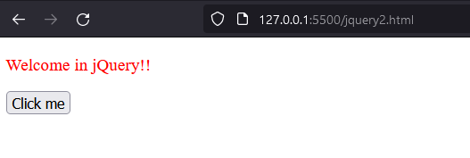

Practical 8.b)

Aim: jQuery Callback, jQuery Get and Set Contents.

1. Write a Jquery effect method with a callback function.

Code:

<!DOCTYPE html>

<html>

  <head>

    <title></title>

    <script src="jquery.js"></script>

    <script>

      $(document).ready(function () {

        $("button").click(function () {

          $("p").hide("slow", function () {

            alert("The paragraph is now hidden");

          });

        });

      });

    </script>

  </head>

  <body>

    <button>click</button>

    <p>This is a paragraph</p>

  </body>

</html>

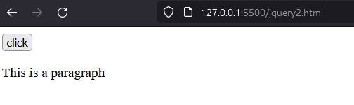Output:

After Clicking button

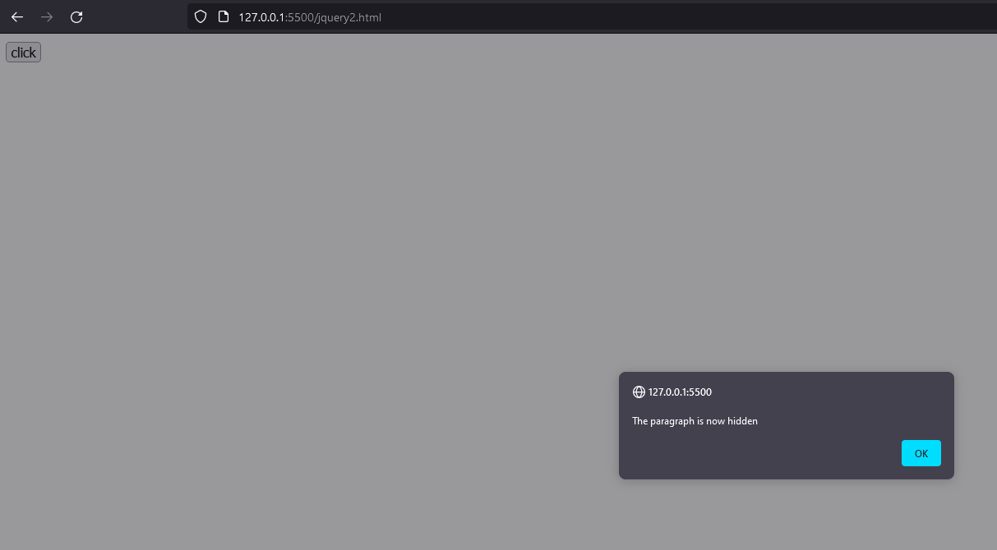

1. Write a Jquery to get and set text contents of the elements.

Code:

<!DOCTYPE html>

<html>

  <head>

    <title></title>

    <script src="jquery.js"></script>

    <script>

      $(document).ready(function () {

        $(".b1").click(function () {

          var str = $("p").text();

          alert(str);

        });

        $(".b2").click(function () {

          $("p").text("This is demo text.");

        });

      });

    </script>

  </head>

  <body>

    <button class="b1">Get All Paragraph's Text</button>

    <p>This is a paragraph.</p>

    <p>This is another paragraph.</p>

    <button class="b2">Set All Paragraph's Text</button>

    <p>This is a test paragraph.</p>

    <p>This is another test paragraph.</p>

  </body>

</html>

Output:

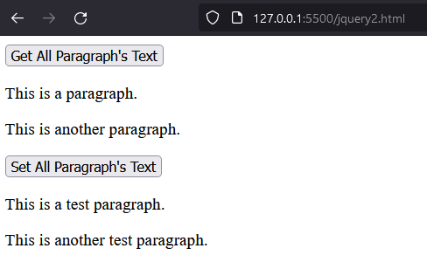

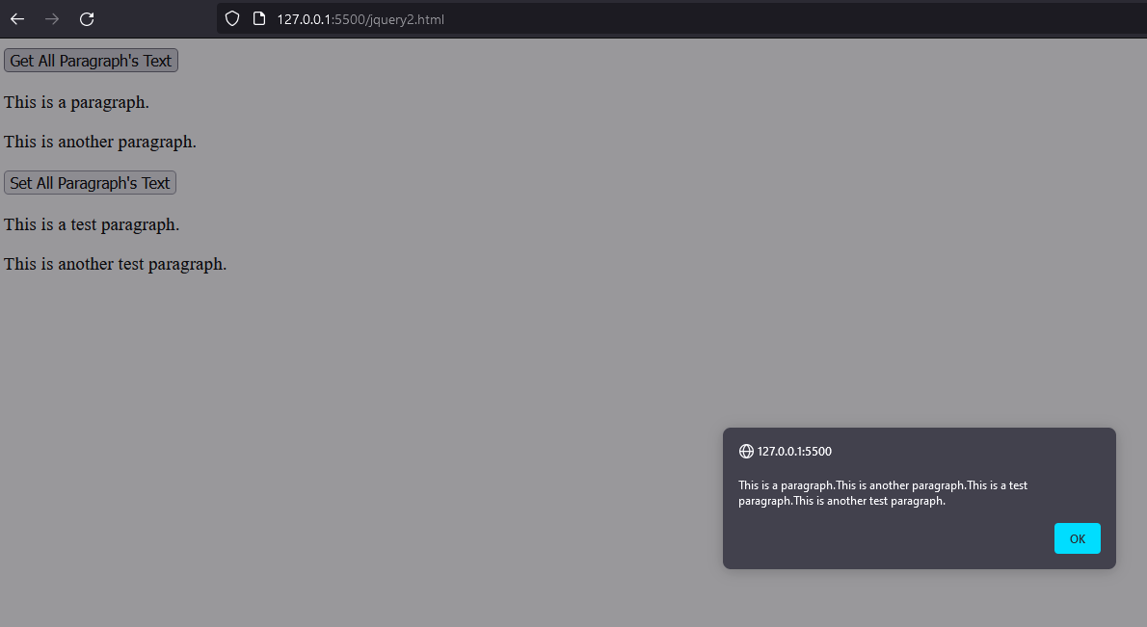 Clicking Get all paragraph’s text

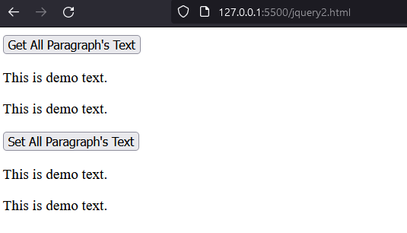Clicking Set all paragraph’s text

1. Write a Jquery to get and set HTML contents of the elements.

Code:

<!DOCTYPE html>

<html>

  <head>

    <title></title>

    <script src="jquery.js"></script>

    <script>

      $(document).ready(function () {

        $(".b1").click(function () {

          var str = $("p").html();

          alert(str);

        });

        $(".b2").click(function () {

          $("body").html("<p>Hello World!</p>");

        });

      });

    </script>

  </head>

  <body>

    <button class="b1">Get Paragraph's HTML Contents</button>

    <p>The quick <b>brown fox</b> jumps over the lazy dog.</p>

    <button class="b2">Write Message</button>

  </body>

</html>

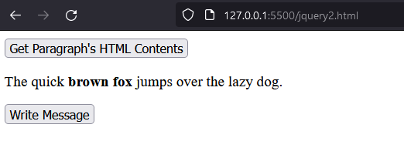Output:

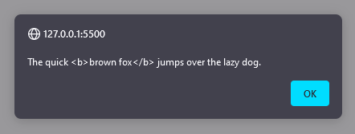 Clicking Get paragraph’s HTML content

Clicking Write message

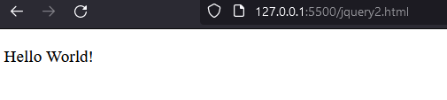

1. Write a Jquery to get and set value of attribute of an element.

Code:

<!DOCTYPE html>

<html>

  <head>

    <title></title>

    <script src="jquery.js"></script>

    <script>

      $(document).ready(function () {

        $(".b1").click(function () {

          var str = $("img#jquery").attr("alt");

          alert(str);

        });

        $(".b2").click(function () {

          $('input[type="checkbox"]').attr("checked", "checked");

        });

      });

    </script>

  </head>

  <body>

    <button class="b1">Get Link's HREF Attribute</button>

    <img id="jquery" src="jquery.png" alt="jquery" height="290px" width="250px" /><br /><br />

    <p><input type="checkbox" />I agree with terms and conditions.</p>

    <button class="b2">Check</button>

  </body>

</html>

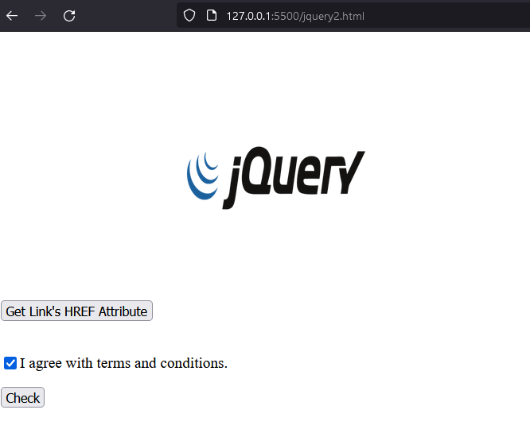Output:

Clicking Get link’s HREF attribute

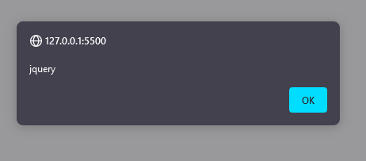

Practical 8.c)

Aim: jQuery Insert Content, jQuery Remove Elements and Attribute.

1. Write a Jquery to insert HTML elements at the beginning and end of the elements.

Code:

<!DOCTYPE html>

<html>

  <head>

    <title></title>

    <script src="jquery.js"></script>

    <script>

      $(document).ready(function () {

        $(".b1").click(function () {

          $("p").prepend("<strong>Note:</strong> ");

        });

        $(".b2").click(function () {

          $("#container").append("This is demo text.");

        });

      });

    </script>

  </head>

  <body>

    <button class="b1">Insert Text at Begin</button>

    <p>welcome in Jquery</p>

    <button class="b2">Insert Text at End</button>

    <div id="container">

      <p>Mulund College of Commerce</p>

    </div>

  </body>

</html>

Output:

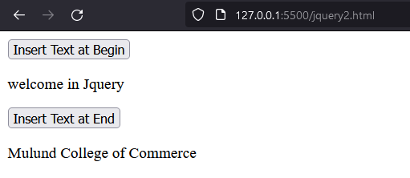

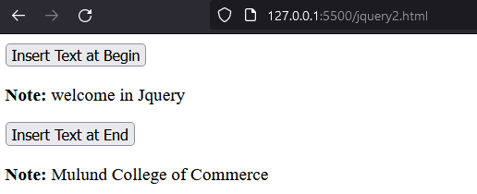 Insert Text at begin

Insert text at end

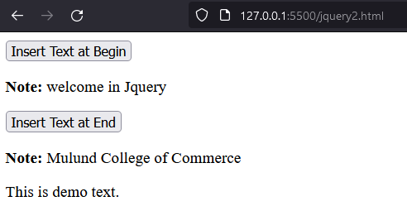

1. Write a Jquery to insert multiple HTML elements at the beginning and end of the elements.

Code:

<!DOCTYPE html>

<html>

  <head>

    <title></title>

    <script src="jquery.js"></script>

    <script>

      $(document).ready(function () {

        $(".b1").click(function () {

          var newHeading = "<h1>Important Note:</h1>";

          var newParagraph = document.createElement("p");

          newParagraph.innerHTML = "<em>hello world</em>";

          $("body").append(newHeading, newParagraph);

        });

      });

    </script>

  </head>

  <body>

    <button class="b1">Insert Contents</button>

    <p>Lorem ipsum dolor sit amet, consectetur adipiscing elit.</p>

  </body>

</html>

Output:

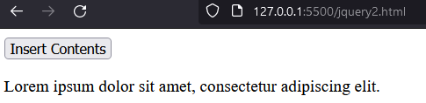

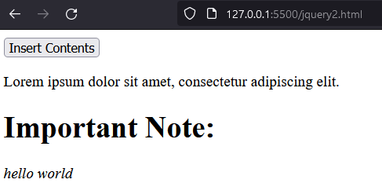

1. Write a Jquery to insert multiple HTML elements before and after the elements.

Code:

<!DOCTYPE html>

<html>

  <head>

    <title></title>

    <script src="jquery.js"></script>

    <script>

      $(document).ready(function () {

        $(".b1").click(function () {

          var newHeading = "<h1>Important Note:</h1>";

          var newParagraph = document.createElement("p");

          newParagraph.innerHTML = "<em>Lorem Ipsum is dummy text...</em>";

          $("p").before(newHeading, newParagraph);

        });

        $(".b2").click(function () {

          var newHeading = "<h1>Important Note:</h1>";

          var newParagraph = document.createElement("p");

          newParagraph.innerHTML = "<em>Lorem Ipsum is dummy text...</em>";

          $("body").append(newHeading, newParagraph);

        });

      });

    </script>

  </head>

  <body>

    <button class="b1">Insert Contents Begin</button>

    <p>Lorem ipsum dolor sit amet, consectetur adipiscing elit.</p>

    <button class="b2">Insert Contents End</button>

  </body>

</html>

Output:

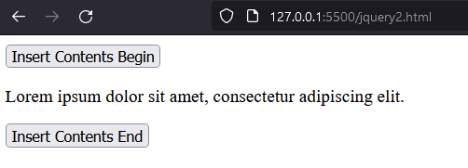

*Insert at beginning*

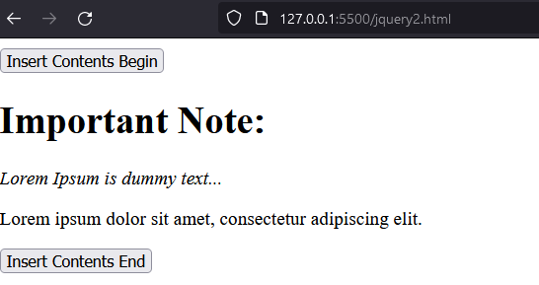

*Insert at end*

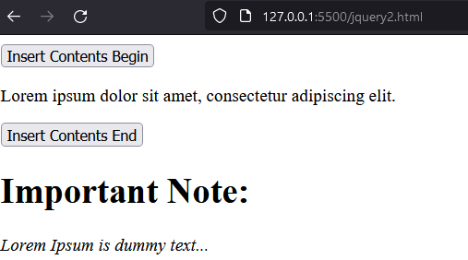

1. Write a Jquery to remove the contents of the elements.

Code:

<!DOCTYPE html>

<html>

  <head>

    <title></title>

    <script src="jquery.js"></script>

    <script>

      $(document).ready(function () {

        $(".btn").click(function () {

          $("div#demo").remove();

        });

      });

    </script>

  </head>

  <body>

    <div id="demo">

      <p>Inside Div Element</p>

    </div>

    <p>Outside Div element</p>

    <button class="btn">Hide the elements inside div</button>

  </body>

</html>

Output:

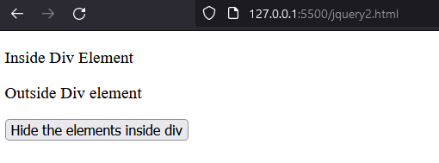

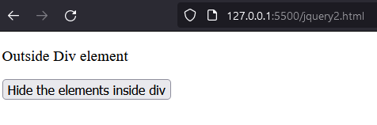

1. Write a Jquery to remove the parent element of an HTML element from the page.

Code:

<!DOCTYPE html>

<html>

  <head>

    <title></title>

    <script src="jquery.js"></script>

    <script>

      $(document).ready(function () {

        $("button").click(function () {

          $("p").unwrap();

        });

      });

    </script>

    <style>

      div {

        background-color: yellow;

      }

      article {

        background-color: pink;

      }

    </style>

  </head>

  <body>

    <div>

      <p>This is a paragraph inside a div element.</p>

    </div>

    <article>

      <p>This is a paragraph inside an article element.</p>

    </article>

    <button>Remove the parent element of each p element</button>

  </body>

</html>

Output:

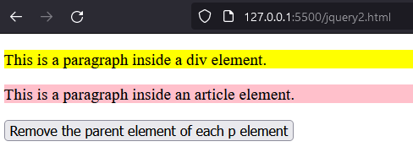

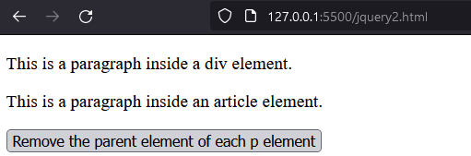

1. Write a Jquery to remove an attribute from the HTML elements.

Code:

<!DOCTYPE html>

<html>

  <head>

    <title></title>

    <script src="jquery.js"></script>

    <script>

      $(document).ready(function () {

        $("button").click(function () {

          $("p").removeAttr("style");

        });

      });

    </script>

    <style>

      div {

        background-color: yellow;

      }

      article {

        background-color: pink;

      }

    </style>

  </head>

  <body>

    <h1>This is a heading</h1>

    <p style="font-size: 120%; color: red">This is a paragraph.</p>

    <p style="font-weight: bold; color: blue">This is another paragraph.</p>

    <button>Remove the style attribute from all p elements</button>

  </body>

</html>

Output:

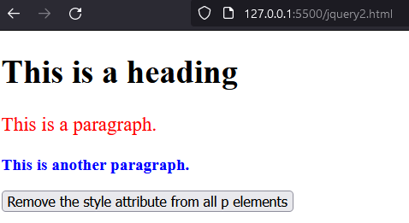

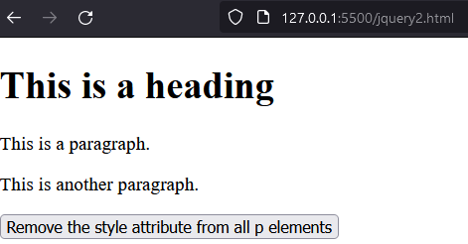

1. Write a Jquery to add and remove CSS classes from the HTML elements.

Code:

<!DOCTYPE html>

<html>

  <head>

    <title></title>

    <script src="jquery.js"></script>

    <script>

      $(document).ready(function () {

        $("button").click(function () {

          $("p").removeClass("intro");

        });

      });

    </script>

    <style>

      .intro {

        font-size: 120%;

        color: red;

      }

    </style>

  </head>

  <body>

    <h1>This is a heading</h1>

    <p class="intro">This is a paragraph.</p>

    <p class="intro">This is another paragraph.</p>

    <button>Remove the "intro" class from all p elements</button>

  </body>

</html>

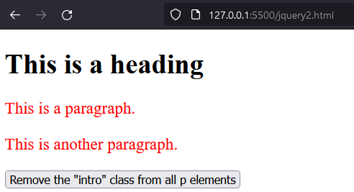Output:

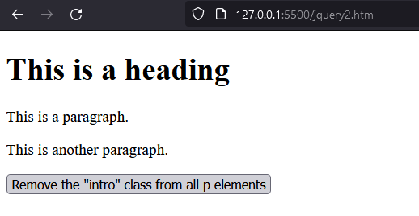

1. Write a Jquery to set the duration in slide toggle effect.

Code:

<!DOCTYPE html>

<html>

  <head>

    <title></title>

    <script src="jquery.js"></script>

    <script>

      $(document).ready(function () {

        $(".b1").click(function () {

          $(".box").slideToggle();

        });

      });

    </script>

  </head>

  <body>

    <button type="button" class="b1">Slide Toggle</button>

    <hr />

    <div class="box">

      <div class="box-inner">

        Lorem ipsum dolor sit amet, consectetur adipiscing elit. Nam eu sem

        tempor, varius quam at, luctus dui.

      </div>

    </div>

  </body>

</html>

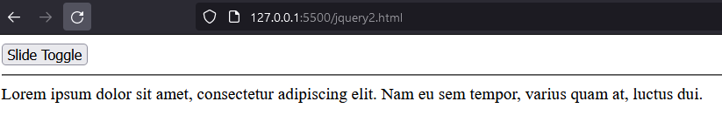Output:

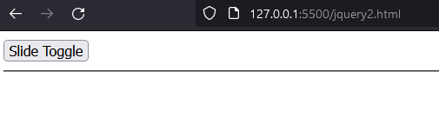

1. Write a Jquery to remove the HTML elements from the page.

Code:

<!DOCTYPE html>

<html>

  <head>

    <title></title>

    <script src="jquery.js"></script>

    <script>

      $(document).ready(function () {

        $("button").click(function () {

          $("#div1").remove();

        });

      });

    </script>

  </head>

  <body>

    <div

      id="div1"

      style="

        height: 100px;

        width: 300px;

        border: 1px solid black;

        background-color: #bcf0f5;

      "

    >

      This is some text in the div.

      <p>This is a paragraph in the div.</p>

      <p>This is another paragraph in the div.</p>

    </div>

    <br />

    <button>Remove div element</button>

  </body>

</html>

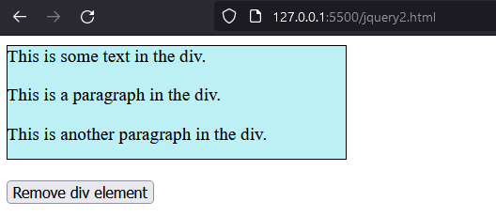Output:

